(Approx. 340 words)

Changing the Mouse Pointer
By Cal Esneault, former President of CCCC and leader of many Open-Source Workshops & SIGs
Cajun Clickers Computer Club
February 2021 issue, CCCC Computer News
www.clickers.org
office (at) clickers.org

A key item in the Windows desktop graphical interface is the “pointer” (controlled by either a mouse or by a laptop touchpad). Since we use it often, finding it quickly makes our sessions more efficient. The default setting has a white pointer with a black outline. It can take time to locate when on a white background (see screenshot below)

Windows 10 (as with previous versions) gives us an easy way to customize this
pointer. From the “Settings” menu, chose the “Ease of Access” item (see below)

Pointer options are shown below.
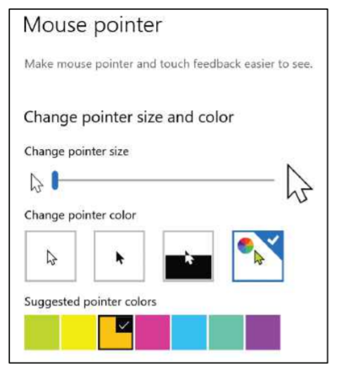
You can change the color of the pointer to any other basic color that you desire.
For example, below the cursor has been changed to a black fill (with white outline) over the same screen as seen earlier. This may allow for improved recognition. Other colors can be selected based on your preference (for example, green or yellow).
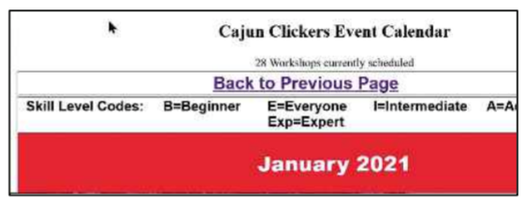
You can also choose the “inverted” option. This changes the color of the pointer depending upon the color of the background. Thus, better contrast is automatically selected, but you must reconcile your mind-muscle connection to accept the fact that the cursor will not always be the same color.

In the mouse pointer dialog, there is also a slider to change the size of the pointer. By default, it is set to “1”, but you can make it larger (for example, “2” or “3) using the slider. This improves recognition, but it takes some getting used to having a large object constantly moving on your screen.

As with any personalization setting, results vary based on your perception of what is “better”. Give it a try to see if this helps. There are many other ways to customize the screen, text, taskbar, dark mode, etc. Search the internet to see if you can find some
that improve your situation.

